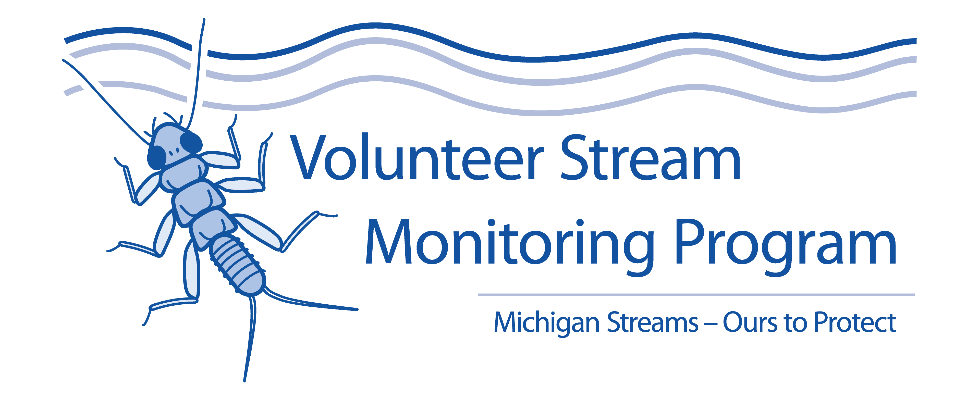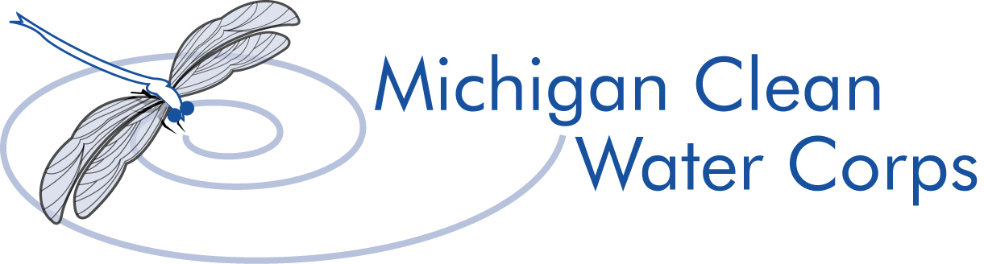

**MiCorps Volunteer Stream Monitoring Program**

**Quarterly Report Narrative**

Organization Name:

Grant Type:

Time Period Covered:

Due Date:

Workplan Progress:

*Directions: Copy/Paste your workplan from your grant contract. Each quarter, comment on progress made for each task and subtask.*

Barriers/Deviations:

*Directions: What problems arose, if any, that disrupted your timeline and work plans? What did you do or plan to do to address the issues? Is there anything you need from MiCorps staff?*